### **Project Proposal Draft 1**

* Game design
  + Single player expected
* Game Description
  + General Idea / Game Narrative
  + Player Goals
  + AI Goals
  + Controls
  + Players
  + Relevant Story
* Specific AI implementations
  + How does the game implement any of the concepts we have discussed in class?
  + Other AI concepts not covered in class also welcome but need to include at least 3 of the following
    - Pathfinding
    - Finite State Machines
    - Sensors
    - Flocks / Crowds
    - Behavior Trees
    - Fuzzy Logic
* Implementation plan
  + Weekly schedule with these dates in mind:
    - Oct 1 - Final Proposal due
    - Oct 22 - Alpha Release
    - Nov 5 - Beta Release
    - Nov 19 - Public Release (In-class demonstration
  + Gantt Chart showing all required tasks, the estimated number of hours/days for completion of the tasks, and the dependencies between tasks.
  + Which members are leading which project pieces
* Prior art / Market research
  + Screenshots/brief descriptions of members’ previous projects
    - "From the studio that brought you..."
  + Other published games with similar gameplay mechanics
* Marketing Plan
  + Website development / design
  + Social media plan
  + Graphic design for Box Art, web advertisement

**Will-o'-Wisp**

**Shantell Burrowes, Alexander Gattis, Brian Ruiz, Bri Dunams, Robert Nealin**

**Game Design:**

Single-player, Top-down RPG

**Game Description:**

General Idea: Protect the forest wisp (an entity that follows the player around) from all monsters until sunrise.

Player Goals: 1. Protect the forest wisp. 2. Defeat all enemies. 3. Collect different colored mana power-ups to defeat

AI Goals: Stop the player from clearing the map of enemies and escaping with the wisp.

Opt AI Goals: Wisp giving Health or a type of boost to the player

Opt AI Goals: Monsters spawning or calling for more monsters to fight against the player 1 out 45% to 75 % of the time

Controls: Keyboard for movement (Keybinding available) and mouse for attacking.

Relevant Story: You the player are trapped in an enchanted forest during the blood moon. The forest is full of bloodthirsty monsters who want to ensure you don’t escape with the magical forest wisp. Fend off all monsters with your newly acquired majic until sunrise to escape this hellhold.

**Specific AI implementations:**

* Pathfinding - Example, enemy and wisp(agent) movement
* Finite State Machines - Example, enemy behavior
* Flocks / Crowds - Example, enemy hordes

**Implementation plan:**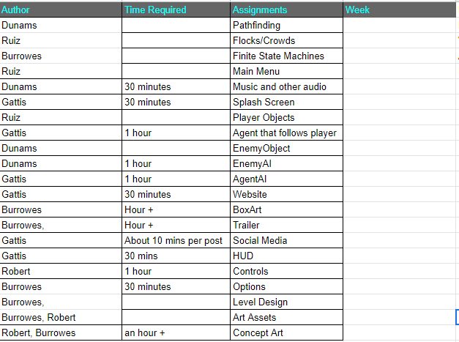

**Prior art / Market research:**

Burrowes Previous Projects: City of the Dead and The Revenger.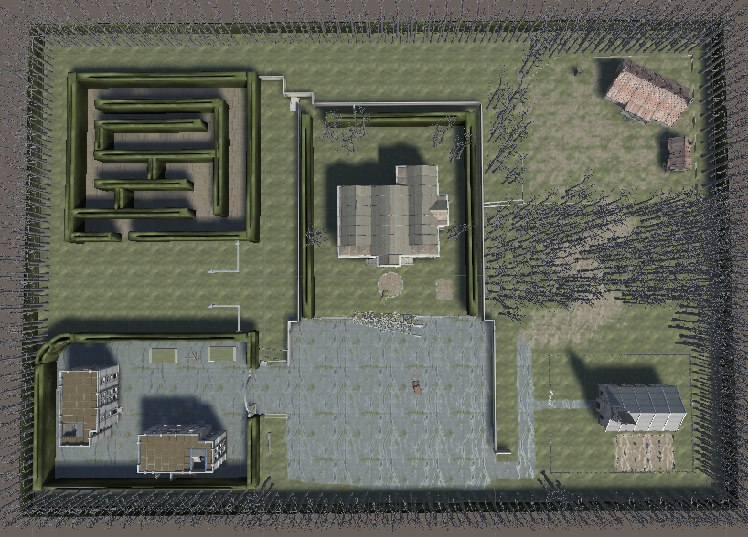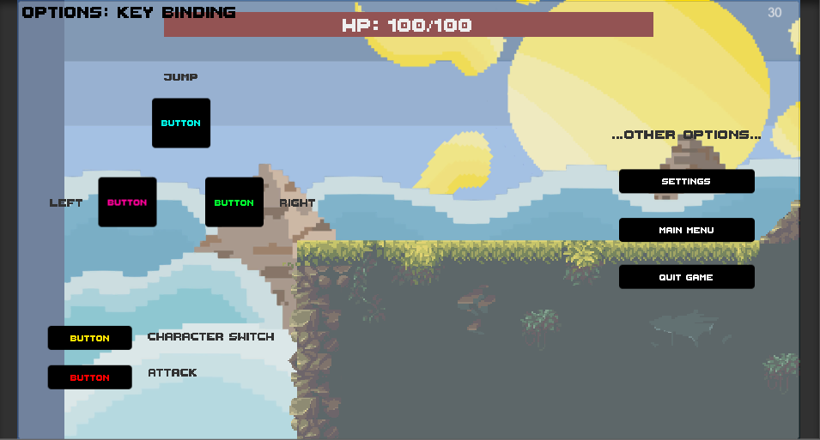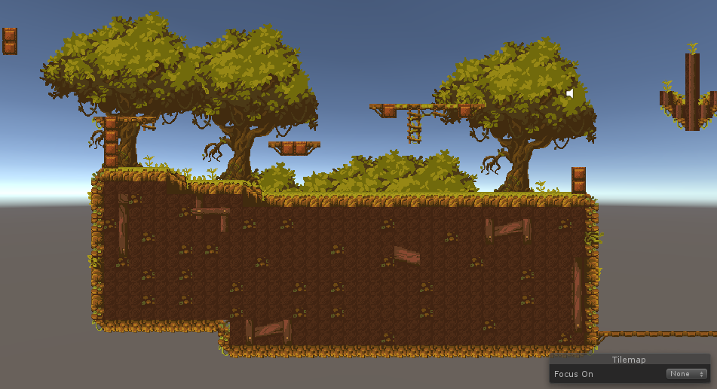

Mainly worked on level/map designs, menu input and smaller coding task.

Alexander Gattis Previous Projects: Dragon King

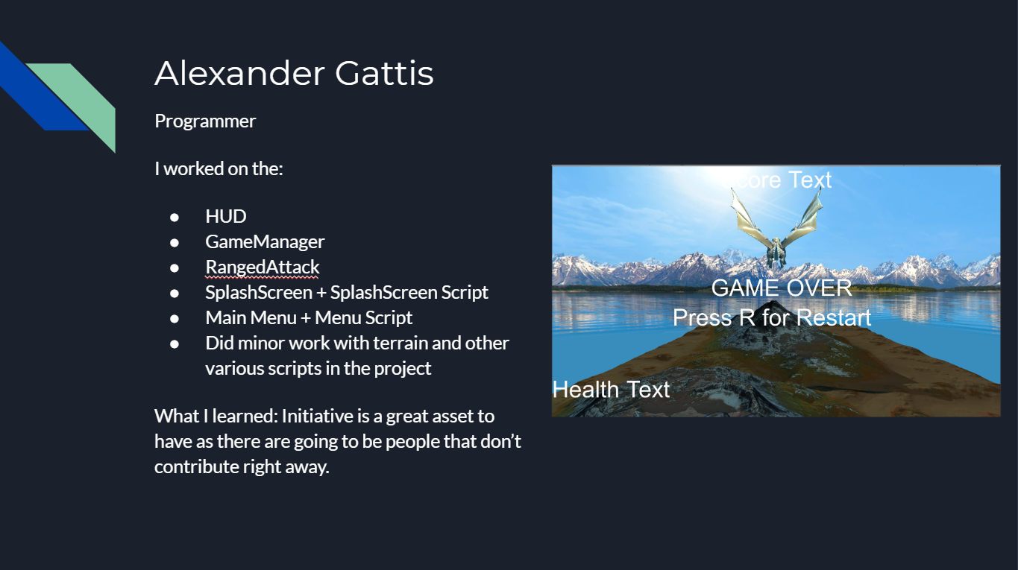

**Similar Games:**

* Enter the Gungeon
* Hotline Miami

**Marketing Plan:**

We will make a Twitter account for the game detailing the development process.

*Twitter -Robert Nealin /@DarkKrow13